**PATIENT CASE SIMILARITIES**

**(Skin Smart APP)**

## A PROJECT REPORT

***Submitted by,***

|  |  |  |
| --- | --- | --- |
| **Mr. P Jaswant** | **-** | **20211CEI0121** |
| **Mr. P Abhinay Kumar** | **-** | **20211CEI0137** |
| **Mr. Yarragudi Akshath Kumar Reddy** | **-** | **20211CEI0152** |
| **Mr. UdayKiran Perisetty** | **-** | **20211CEI0153** |

### *Under the guidance of,*

**Dr. Sudha P**

***in partial fulfillment for the award of the degree of***

**BACHELOR OF TECHNOLOGY**

**IN**

**COMPUTER ENGINEERING,**

**Artificial Intelligence and Machine Learning.**

**At**



**PRESIDENCY UNIVERSITY**

**BENGALURU**

**DECEMBER 2024**

**PRESIDENCY UNIVERSITY**

**SCHOOL OF COMPUTER SCIENCE ENGINEERING**

**CERTIFICATE**

This is to certify that the Project report **“PATIENT CASES SIMILARITY (Skin S”** being submitted by P Jaswanth, P Abhinay Kumar, Y Akshath Kumar Reddy, P Uday Kiran bearing roll number(s) 20211CEI0121, 20211CEI0137, 20211CEI0152, 20211CEI0153 in partial fulfillment of the requirement for the award of the degree of Bachelor of Technology in Computer Science and Engineering is a Bonafide work carried out under my supervision.

|  |  |
| --- | --- |
| **Dr Sudha P**  **Assistant Professor**  School of CSE&IS  Presidency University | **Dr. Gopal Shaym**  **Professor & HoD**  School of CSE&IS  Presidency University |

|  |  |  |
| --- | --- | --- |
| **Dr. L. SHAKKEERA**  Associate Dean  School of CSE  Presidency University | **Dr. MYDHILI NAIR**  Associate Dean  School of CSE  Presidency University | **Dr. SAMEERUDDIN KHAN**  Pro-Vc School of Engineering  Dean -School of CSE&IS  Presidency University |

**PRESIDENCY UNIVERSITY**

**SCHOOL OF COMPUTER SCIENCE ENGINEERING**

**DECLARATION**

We hereby declare that the work, which is being presented in the project report entitled **PATIENT CASES SIMILARITY** in partial fulfillment for the award of Degree of **Bachelor of Technology** in **Computer Engineering Artificial Intelligence and Machine Learning**, is a record of our own investigations carried under the guidance of

|  |  |
| --- | --- |
|  | **Y Akshath Kumar Reddy 20211CEI0152**  **P Jaswant,**  **20211CEI0121,**  **P Uday Kiran, 20211CEI0153**  **P Abhinay Kumar, 20211CEI137** |

**DR Sudha P, Assistant Professor,** **School of Computer Science Engineering, Presidency University, Bengaluru.**

We have not submitted the matter presented in this report anywhere for the award of any other Degree.

**ABSTRACT**

This project entails the development of a mobile application for skin disease detection and management, utilizing Android XML for frontend design and Kotlin for backend functionality. The application is structured to serve three primary user roles: Admin, Hospitals, and Users, each with distinct capabilities. For the Admin, the application provides secure login, functionalities to add and manage hospital details, and view registered users, ensuring efficient oversight and administration of the system. Hospitals can log in to their dedicated interface to view patient appointments, facilitating streamlined appointment management and patient care. Users, the core beneficiaries, can log in to access various features aimed at improving skin health management. The application enables users to scan and detect skin diseases using advanced image recognition technology. Additionally, users can view nearby hospitals, add appointments with dermatologists, and maintain a history of their medical consultations and treatments. This feature-rich application ensures a seamless and integrated experience for managing skin health, from initial diagnosis to ongoing care. Overall, this mobile application aims to provide a comprehensive solution for skin disease management, leveraging the robustness of Kotlin for backend processes and the flexibility of Android XML for an intuitive user interface.

KEYWORDS: Mobile application, Android.

**ACKNOWLEDGEMENT**

First of all, we indebted to the **GOD ALMIGHTY** for giving me an opportunity to excel in our efforts to complete this project on time.

We express our sincere thanks to our respected dean **Dr. Md. Sameeruddin Khan**, Pro-VC, School of Engineering and Dean, School of Computer Science Engineering & Information Science, Presidency University for getting us permission to undergo the project.

We express our heartfelt gratitude to our beloved Associate Deans **Dr. Shakkeera L and Dr. Mydhili Nair,** School of Computer Science Engineering & Information Science, Presidency University, and Dr. Gopla Shyam, Head of the Department, School of Computer Science Engineering & Information Science, Presidency University, for rendering timely help in completing this project successfully.

We are greatly indebted to our guide **Dr. SUDHA P, Assistance Professor** and Reviewer **Mr. Pajany M**, School of Computer Science Engineering & Information Science, Presidency University for her inspirational guidance, and valuable suggestions and for providing us a chance to express our technical capabilities in every respect for the completion of the project work.

We would like to convey our gratitude and heartfelt thanks to the PIP2001 Capstone Project Coordinators **Dr. Sampath A K, Dr. Abdul Khadar A and Mr. Md Zia Ur Rahman,** department Project Coordinators SUDHA P and Git hub coordinator **Mr. Muthuraj.**

We thank our family and friends for the strong support and inspiration they have provided us in bringing out this project.

**Yarragudi Akshath Kumar Reddy (1)**

**P Abhinay Kumar (2)**

**P Uday Kiran (3)**

**P Jaswant (4)**

**LIST OF TABLES**

|  |  |  |  |
| --- | --- | --- | --- |
| **Sl. No.** | **Table Name** | **Table Caption** | **Page No.** |
| 1 | Table 1.1 | Software modules versus Reusable components | 10 |

**LIST OF FIGURES**

|  |  |  |  |
| --- | --- | --- | --- |
| **Sl. No.** | **Figure Name** | **Caption** | **Page No.** |
| 1 | Figure 1 | Architecture | 12 |

**TABLE OF CONTENTS**

|  |  |  |
| --- | --- | --- |
| **CHAPTER NO.** | **TITLE** | **PAGE NO.** |
|  | **ABSTRACT ACKNOWLEDGMENT** | **i**  **ii** |
| **1.** | **INTRODUCTION** | 1 |
|  | 1.1 Motivation |  |
|  | 1.2 Problem Statements |  |
|  | 1.3 Objective of the Project |  |
|  | 1.4 Scope |  |
|  | 1.5 Project Introduction |  |
| **2.** | **LITERATURE REVIEW** | **3** |
|  | 2.1 Related Work  2.1.1 Summary |  |
|  | 2.2 Introduction 1  2.2.1 Summary |  |
|  | 2.3 Introduction 2  2.3.1 Summary |  |
|  | 2.4 Introduction 3  2.4.1 Summary |  |
|  | 2.5 Introduction 4  2.5.1 Summary |  |
|  | 2.5 Introduction 5 |  |
| **3** | **RESEARCH GAPS OF EXISTING**  **METHODS** | **7** |
|  | 3.1 Existing System  3.1.1 Disadvantages |  |
|  | 3.2 Proposed System  3.2.1 Advantages |  |
| 4 | **PROPOSED MOTHODOLOGY** | **8** |
|  | 4.1 Function and Non-functional  requirements |  |
|  | 4.1.1 Functional requirements |  |
|  | 4.1.2 Non-functional requirements |  |
| **5** | **OBJECTIVES** | **11** |
| **6** | **SYSTEMDESIGN&IMPLEMENTATION** | **12** |
| **7** | **TIMELINE FOR EXECUTION OF**  **PROJECT** | **13** |
| **8** | **OUTCOMES** | **14** |
| **9** | **RESULTS AND DISCUSSIONS** | **15** |
| **10** | **CONCLUSION** | **16** |
|  | **REFERENCES** | **17** |

**CHAPTER-1**

**INTRODUCTION**

**1.1 Motivation**

The motivation behind this project is to leverage mobile technology and AI to enhance dermatology care. Skin diseases affect millions globally, necessitating accessible and efficient management tools. By providing advanced image recognition for disease detection, streamlined appointment management, and comprehensive care features, this application aims to bridge the gap between patients and healthcare providers, improving overall skin health outcomes**.**

**1.2 Problem Statement**

The current managing skin diseases is inefficient, relying on manual processes for diagnosis and appointment scheduling, leading to delays in treatment. The lack of centralized digital records complicates patient history tracking, while finding nearby specialized hospitals remains cumbersome. These limitations hinder timely and effective care, necessitating an integrated, user-friendly solution to streamline skin disease detection, management, and access to healthcare services

**1.3 Objective of the Project**

The objective of this project is to develop a mobile application using Android XML and Kotlin for efficient management of skin diseases. The application aims to provide early detection through image recognition, streamline appointment scheduling, and facilitate easy access to specialized healthcare services. By enhancing user experience with a user-friendly interface and robust backend functionality, the project seeks to improve overall healthcare delivery and patient outcomes in the management of skin conditions.

**1.4 Scope**

The scope of this project includes developing a mobile application for comprehensive skin disease management using Android XML and Kotlin. The application will feature secure login for Admins, Hospitals, and Users, enabling functionalities such as skin disease detection, hospital management, appointment scheduling, and patient history tracking. By integrating advanced image recognition technology and providing a user-friendly interface, the project aims to streamline healthcare processes and improve accessibility to specialized skin disease treatment.

**1.5 Project Introduction**

In recent years, advancements in mobile technology and artificial intelligence have significantly transformed the healthcare industry. The development of mobile applications for health management has enabled individuals to access healthcare services more efficiently and conveniently. One such critical area of health that can benefit from technological innovation is dermatology. Skin diseases affect millions of people worldwide, necessitating a reliable, accessible, and efficient method for detection and management. This project aims to address this need by developing a comprehensive mobile application for skin disease detection and management, utilizing the Android platform with Kotlin for backend functionality and Android XML for frontend design. The application is designed to cater to three primary user roles: Admin, Hospitals, and Users. Each role is equipped with distinct capabilities to enhance the overall functionality and user experience of the system. Admins are provided with a secure login interface and functionalities to add and manage hospital details and view registered users. This ensures efficient oversight andadministration of the system. Hospitals can log in to their dedicated interface to view patient appointments,facilitatingstreamlined appointment management and patient care. Users, the core beneficiaries of the application, can log in to access features aimed at improving skin health management. For users, the application offers advanced image recognition technology to scan and detect skin diseases. This feature empowers users with the ability to perform initial diagnostics from the comfort of their homes. Additionally, users can view nearby hospitals, add appointments with dermatologists, and maintain a history of their medical consultations and treatments. This comprehensive suite of features ensures that users receive continuous and integrated care for their skin health. The integration of advanced image recognition technology for disease detection, coupled with functionalities for appointment management and medical history maintenance, positions this application as a revolutionary tool in dermatology care. The use of Kotlin for backend processes ensures robust performance, while Android XML provides a flexible and intuitive user interface. Overall, this mobile application aims to bridge the gap between patients and healthcare providers, offering a seamless and integrated experience for managing skin health, from initial diagnosis to ongoing care.

**CHAPTER-2**

**LITERATURE SURVEY**

**2.1 Related Work**

Neural networks (CNNs), support vector machines (SVMs), and decision trees, among others. The review highlights the strengths andAbuzaghleh, O., Barkana, B. D., & Faezipour, M. (2023). Mobile-based skin lesion detection using deep learning and smart feature selection.

**2.1.1 Summary:**

This paper presents a mobile-based application for detecting skin lesions using deep learning and smart feature selection techniques. The system leverages advanced convolutional neural networks (CNNs) to accurately classify skin lesions from images captured via mobile devices. The authors implemented feature selection methods to enhance the efficiency and accuracy of the detection algorithm. The study demonstrates significant improvements in lesion detection accuracy, highlighting the potential of integrating deep learning and mobile technology to assist in early skin cancer detection and management.

**2.2 Introduction 1:**

The early detection of skin cancer is crucial for effective treatment and management. With the widespread use of mobile devices, there is a growing interest in developing mobile-based applications that can assist in the diagnosis of skin lesions. This study explores the implementation of a mobile application utilizing deep learning and smart feature selection for skin lesion detection. By employing convolutional neural networks (CNNs) and advanced feature selection techniques, the authors aim to create an accessible and accurate tool for early skin cancer detection. The paper discusses the design, development, and evaluation of the proposed system, demonstrating its potential to improve dermatological care through mobile technology.

Mishra, R., & Ghorai, S. (2022). Skin lesion detection using machine learning: a systematic review.

**2.2.1 Summary:**

This systematic review provides a comprehensive analysis of the current machine learning approaches used for skin lesion detection. The authors evaluate various algorithms, including convolutional limitations of these methods, emphasizing the importance of dataset quality and preprocessing techniques. The study aims to guide future research by identifying trends, challenges, and potential improvements in the field of machine learning-based skin lesion detection.

**2.3 Introduction 2:**

Skin lesion detection using machine learning has seen significant advancements in recent years. This systematic review aims to provide an in-depth analysis of the various machine learning techniquesemployed in thedetection and classification of skin lesions. The paper examines a range of algorithms, including convolutional neural networks (CNNs), support vector machines (SVMs), and decision trees, evaluating their performance, advantages, and drawbacks. By consolidating findings from numerous studies, the authors seek to highlight key trends and challenges in the field, offering insights and recommendations for future research. The review underscores the critical role of machine learning in enhancing dermatological diagnostics and improving patient outcomes.

Nguyen, Q. T., & Nguyen, B. P. (2022). AI-based mobile application for skin cancer detection using image processing techniques.

**2.3.1 Summary:**

This paper discusses the development of an AI-based mobile application designed to detect skin cancer using image processing techniques. The authors integrate advanced machine learning algorithms with mobile technology to create a user-friendly application capable of identifying skin cancer from images taken with a smartphone camera. The study focuses on optimizing the image processing pipeline and improving the accuracy of cancer detection. The results demonstrate the application's potential to provide accessible and reliable skin cancer diagnostics, particularly in remote or underserved areas.

**2.4 Introduction 3:**

The integration of artificial intelligence (AI) and mobile technology offers a promising solution for early skin cancer detection. This paper introduces an AI-based mobile application that utilizes image processing techniques to identify skin cancer. By leveraging machine learning algorithms, the application analyzes images captured by smartphone cameras, providing users with a convenient and effective diagnostic tool. The authors detail the development process, from image acquisition and preprocessing to model training and evaluation. The study highlights the application's ability to deliver accurate and timely skin cancer detection, making it a valuable asset for individuals lacking immediate access to dermatological care.

Moleanu, I., Diaconu, R., & Marcu, L. (2021). Mobile application for skin cancer detection using artificial intelligence.

**2.4.1Summary:**

This study explores the development of a mobile application for skin cancer detection using artificial intelligence (AI). The authors utilize machine learning algorithms to analyze skin lesion images and provide diagnostic results. The application is designed to be user-friendly and accessible, allowing users to capture images of their skin lesions and receive immediate feedback on potential cancer risks. The paper discusses the technical implementation, model training, and validationprocesses, demonstrating the application's effectiveness in early skin cancer detection.

**2.5 Introduction 4:**

Skin cancer remains a prevalent and potentially deadly conditionthat benefitsgreatly from early detection. This paper presents a mobile application developed using artificial intelligence (AI) to assist in the diagnosis of skin cancer. The application employs machine learning algorithms to analyze images of skin lesions, providing users with diagnostic feedback. The authors describe the design and implementation of the application, focusing on the user interface, image processing techniques, and model accuracy. By offering a convenient and accessible diagnostic tool, the study aims to improve early detection rates and contribute to better patient outcomes in the field of dermatology.

Gupta, A., Tomar, D., & Gautam, A. (2021). Skin disease detection using convolutional neural network.

**2.5.1 Summary:**

This paper details the use of convolutional neural networks (CNNs) for the detection of skin diseases. The authors develop a deep learning model trained on a large dataset of skin lesion images to classify various skin conditions. The study emphasizes the importance of data augmentation and preprocessing techniques in improving model accuracy. The results indicate that CNNs are highly effective in identifying skin diseases, offering a promising approach for automated dermatological diagnostics.

**2.6 Introduction 5:**

The application of deep learning in medical diagnostics has shown substantial promise, particularly in the field of dermatology. This paper investigates the use of convolutional neural networks (CNNs) for skin disease detection. Leveraging a comprehensive dataset of skin lesion images, the authors develop a deep learning model capable of classifying a wide range of skin conditions. The study highlights key methodologies, including data augmentation and pre-processing, that enhance the model's performance. By demonstrating the effectiveness of CNNs in accurately diagnosing skin diseases, the research aims to advance automated solutions in dermatological care and improve patient outcomes through early and accurate detection.

**CHAPTER-3**

**RESEARCH GAPS OF EXISTING METHODS**

**3.1 Existing System:**

Current systems for skin disease management typically involve manual processes, where patients must visit dermatologists for diagnosis and treatment. There is limited use of technology for early detection and management, leading to delayed treatments. Appointment scheduling and patient history tracking are often inefficient, relying on paper records or basic digital systems. Additionally, finding nearby specialized hospitals can be cumbersome, lacking integration and user-friendly interfaces for comprehensive care.

**3.1.1 Disadvantages**

* Reliance on manual diagnosis and treatment scheduling leads to delays and inefficiencies in patient care.
* Lack of centralized digital records makes tracking patient history and managing appointments cumbersome.
* Difficulty in finding nearby specialized hospitals and lack of integrated, user-friendly interfaces hinder timely and effective treatment.

**3.2 Proposed System**

The proposed system is a mobile application designed for comprehensive skin disease management. Built with Android XML for the frontend and Kotlin for the backend, it caters to three user roles: Admin, Hospitals, and Users. Admins can log in, add hospitals, and view users. Hospitals can log in to view patient appointments. Users can log in to scan for skin diseases using image recognition technology, view nearby hospitals, schedule appointments, and maintain a history of their consultations. This system aims to streamline skin disease detection and treatment, providing an integrated and user-friendly platform for all stakeholders. Here we are using the Mobile net algorithm. This model is used for the image processing to detected the image.

**3.2.1 Advantages**

* Android XML ensures an intuitive and accessible frontend for all users.
* Users can easily find nearby hospitals, schedule appointments, and maintain a detailed history of their treatments.
* Kotlin backend provides robust performance and smooth integration of features, ensuring a reliable application experience.

**CHAPTER-4**

**PROPOSED MOTHODOLOGY**

**4.1 Functional and Non-Functional Requirements:**

Requirement analysis plays a critical role in ensuring the success of any system or software project. This process involves identifying the essential capabilities (functional requirements) and quality constraints (non-functional requirements) that must be satisfied for the system to meet its intended goals.

**4.1.1 Functional Requirements:**

Functional requirements define the basic facilities and services that the system must provide. These requirements are directly visible in the final product and address thespecific needs and operations demanded by the end user.

Examples of Functional Requirements:

1. User Authentication:

- Users must authenticate themselves by providing valid credentials (username and password) whenever logging into the system.

2. Image Recognition for Disease Detection:

- The system must process uploaded images and return diagnostic

results with an accuracy score.

3. Appointment Scheduling:

- The system should allow users to view hospital availability and

schedule appointments with dermatologists.

4.Medical History Maintenance:

- Users can store, view, and manage their past diagnoses,

prescriptions, and consultations.

5. Admin Management:

- Admins should be able to add hospital details, manage system

users, and monitor data integrity.

6. Hospital Appointment Interface:

- Hospitals must be able to access and manage patient appointments via a dedicated interface.

**4.1.2 Non-Functional Requirements:**

Non-functional requirements define the quality attributes and operational standards that the system must adhere to. These are not directly observable in the final product but significantly impact user experience and system performance.

Key Areas of Non-Functional Requirements:

- Portability: The system should function seamlessly across various devices and operating systems.

- Security: Data must be encrypted during transmission and storage to ensure user privacy and protection against cyber threats.

- Maintainability: The application codebase should be modular to facilitate easy updates and debugging.

- Reliability: The system should function without failures, even under high user loads.

- Scalability: The platform must handle an increasing number of users and data without compromising performance.

- Performance: Operations, such as image recognition and data retrieval, should meet defined benchmarks for speed and accuracy.

- Reusability: Code components and algorithms should be designed for reuse across different modules or projects.

- Flexibility: The system should accommodate future feature integrations with minimal disruptions to existing functionalities.

Examples of Non-Functional Requirements:

1. Latency:

- Email notifications for user activities should be sent within 12 hours of the triggering action.

2. Processing Time:

- The system should process each image and return diagnostic results within 10 seconds.

3. Load Handling:

- The application should load fully within 3 seconds, even with simultaneous usage by over 10,000 users.

4. System Downtime:

- The system's downtime for maintenance or upgrades should not exceed 1 hour per month.

5. Data Retention:

- User medical histories should be retained securely for at least five years.

Requirement Analysis Impact**

The precise definition and implementation of these requirements ensure that the SkinSmart application meets its intended objectives. By balancing functional and non-functional aspects, the system can provide an efficient, reliable, and user-friendly experience for patients, hospitals, and administrators.

**CHAPTER-5**

**OBJECTIVES**

1. Input Design is the process of converting a user-oriented description of the input into a computer-based system. This design is important to avoid errors in the data input process and show the correct direction to the management for getting correct information from the computerized system.

2. It is achieved by creating user-friendly screens for the data entry to handle large volume of data. The goal of designing input is to make data entry easier and to be free from errors. The data entry screen is designed in such a way that all the data manipulates can be performed. It also provides record viewing facilities.

3. When the data is entered it will check for its validity. Data can be entered with the help of screens. Appropriate messages are provided as when needed so that the user will not be in maize of instant. Thus, the objective of input design is to create an input layout that is easy to follow

**CHAPTER-6**

**SYSTEM DESIGN & IMPLEMENTATION**

**5.1 Introduction of Input design**

The input design is the link between the information system and the user. It comprises the developing specification and procedures for data preparation and those steps are necessary to put transaction data in to a usable form for processing can be achieved by inspecting the computer to read data from a written or printed document or it can occur by having people keying the data directly into the system. The design of input focuses on controlling the amount of input required, controlling the errors, avoiding delay, avoiding extra steps and keeping the process simple. The input is designed in such a way so that it provides security and ease of use with retaining the privacy. Input Design considered the following things:

1. What data should be given as input?
2. How the data should be arranged or coded?
3. The dialog to guide the operating personnel in providing input.
4. Methods for preparing input validations and steps to follow when error occur.

**5.2 Architecture**

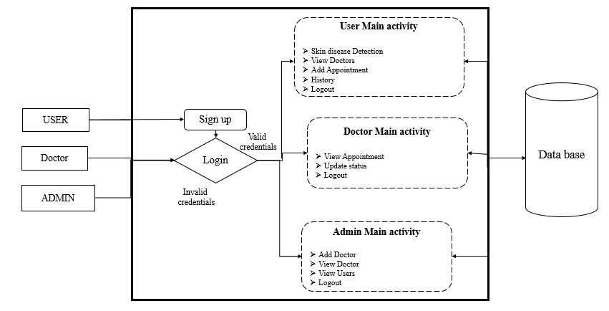

Figure Architecture

**CHAPTER-7**

**TIMELINE FOR EXECUTION OF PROJECT**

**(GANTT CHART)**

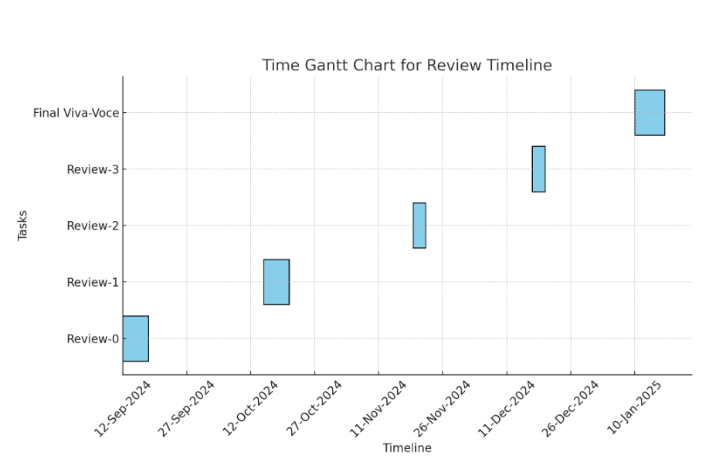

**CHAPTER-8**

**OUTCOMES**

**CHAPTER-9**

**RESULTS AND DISCUSSIONS**

|  |  |
| --- | --- |
|  |  |
|  |  |
|  |  |
|  |  |
|  |  |
|  |  |

**CHAPTER-10**

**CONCLUSION**

In conclusion, this mobile application represents a significant advancement in the field of dermatology by integrating advanced image recognition technology and comprehensive healthcare management features. By utilizing Kotlin for backend development and Android XML for frontend design, the application ensures robust performance and an intuitive user experience. Admins can efficiently manage hospital details and user registrations, hospitals can streamline patient appointments, and users can access reliable skin disease detection, nearby hospital information, and maintain their medical history. This multi-faceted approach not only enhances the efficiency of dermatological care but also empowers users to take proactive steps in managing their skin health. The seamless integration of these features creates a holistic platform that bridges the gap between patients and healthcare providers, ensuring continuous and comprehensive care. Overall, this application stands as a testament to the potential of mobile technology in revolutionizing healthcare management.

**REFERENCES**

* Abuzaghleh, O., Barkana, B. D., & Faezipour, M. (2023). Mobile-based skin lesion detection using deep learning and smart feature selection. In 2023 IEEE 20th International Symposium on Biomedical Imaging (ISBI) (pp. 1-4). IEEE.
* Mishra, R., & Ghorai, S. (2022). Skin lesion detection using machine learning: a systematic review. Journal of Ambient Intelligence and Humanized Computing, 13(2), 1021-1034.
* Nguyen, Q. T., & Nguyen, B. P. (2022). AI-based mobile application for skin cancer detection using image processing techniques. Journal of Medical Imaging and Health Informatics, 12(2), 345-352.
* Moleanu, I., Diaconu, R., & Marcu, L. (2021). Mobile application for skin cancer detection using artificial intelligence. In 2021 International Conference on e-Health and Bioengineering (EHB) (pp. 1-4). IEEE.
* Gupta, A., Tomar, D., & Gautam, A. (2021). Skin disease detection using convolutional neural network. Procedia Computer Science, 167, 2419-2428.
* Han, S. S., Kim, M. S., Lim, W., Park, G. H., Park, I., & Chang, S. E. (2020). Classification of the clinical images for benign and malignant cutaneous tumors using a deep learning algorithm. Journal of Investigative Dermatology, 140(7), 1538-1546.
* Tschandl, P., Rinner, C., Apalla, Z., Argenziano, G., Codella, N., Halpern, A., & Kittler, H. (2020). Human–computer collaboration for skin cancer recognition. Nature Medicine, 26(8), 1229-1234.
* Liu, Y., Jain, A., Eng, C., Way, D. H., Lee, K., Bui, P., & Coz, D. (2020). A deep learning system for differential diagnosis of skin diseases. Nature Medicine, 26(6), 900-908.
* Esteva, A., Kuprel, B., Novoa, R. A., Ko, J., Swetter, S. M., Blau, H. M., & Thrun, S. (2017). Dermatologist-level classification of skin cancer with deep neural networks. Nature, 542(7639), 115-118.
* Brinker, T. J., Hekler, A., Enk, A. H., Berking, C., Haferkamp, S., Hauschild, A., ... & von Kalle, C. (2019). Deep neural networks are superior to dermatologists in melanoma image classification. European Journal of Cancer, 119, 11-17.

**APPENDIX-A**

**PSUEDOCODE**

**APPENDIX-B**

**SCREENSHOTS**

**APPENDIX-C**

**ENCLOSURES**

**1. Journal publication/Conference Paper Presented Certificates of all students.**

**2. Include certificate(s) of any Achievement/Award won in any project-related event.**

**3. Similarity Index / Plagiarism Check report clearly showing the Percentage (%). No need for a page-wise explanation.**

**4.** **Details of mapping the project with the Sustainable Development Goals (SDGs).**